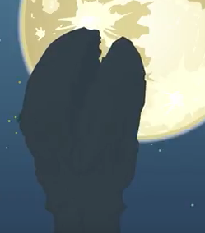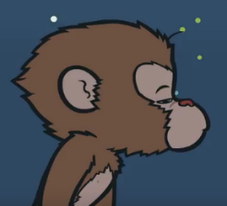
Narrator | A long time ago, the Monkey king woke from his stone.
Monkey King | Wǒ hěn léi 。
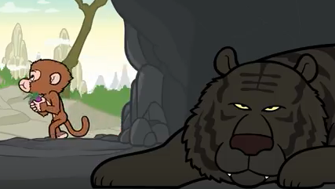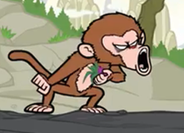
Narrator | Suddenly, the Monkey King spotted a tiger in a dark cave.
Monkey King | Wǒ hěn shēngqì 。
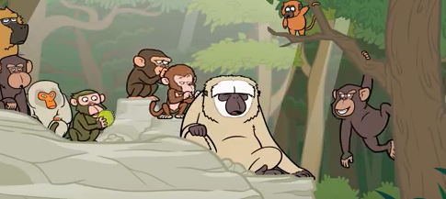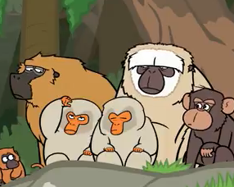
Narrator | Then he became very hot and went to rest in the shade with his friends.
Monkeys | Wǒmén hěn rè 。
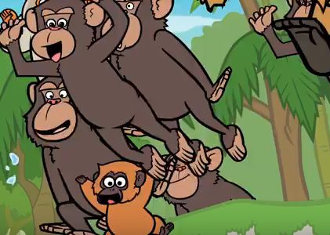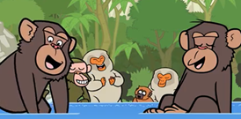
Narrator | They decided to jump in the stream to cool down.
Monkeys | Wǒmén hěn gāoxīng 。
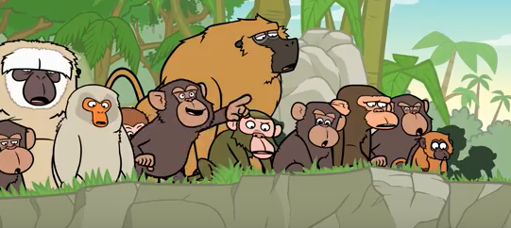
Narrator | The monkeys followed the stream to a waterfall but no one was brave enough to jump through.
Monkeys | Wǒmén hěn hàipà 。
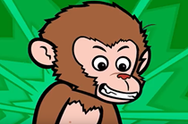
Narrator | The monkey king was not afraid and he dared to jump through to the other side.
Monkey King | Wǒ hěn xīng fèn 。
